Radio Controlled (RC) Car – Detailed Explanation

## 1. Introduction

A Radio Controlled (RC) car is a miniature vehicle operated using radio signals from a remote controller. RC cars are widely used for educational projects, hobby racing, and learning basic concepts of electronics, mechanics, and wireless communication.

## 2. Types of RC Cars

- On-road RC cars  
- Off-road RC cars  
- Drift RC cars  
- Monster trucks  
- Racing RC cars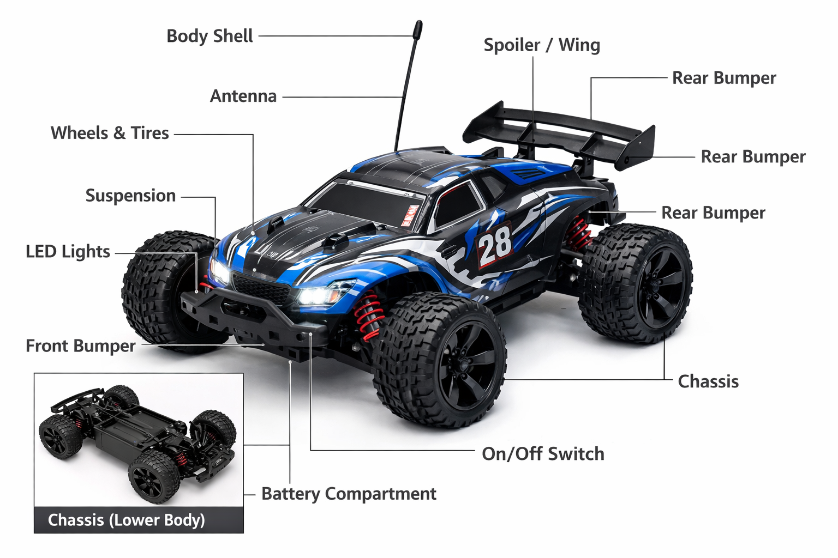

## 3. External Parts of an RC Car

### Body Shell: Protects internal components and gives appearance. Chassis: Main structural frame supporting all parts. Wheels & Tires: Provide traction and stability. Suspension System: Absorbs shocks and improves handling. Bumpers: Protect the car during collisions. Spoiler/Wing: Improves stability at high speed. Antenna: Receives control signals. LED Lights: Used for visibility and realistic look.

### 3.1 Body Shell

* The body shell is the outermost covering of the RC car.
* It is usually made from **polycarbonate or ABS plastic** to make it lightweight yet strong.
* It protects the internal electronic and mechanical components from dust, dirt, and minor impacts.
* The body shell also improves aerodynamics and gives the RC car a realistic look similar to real cars.

### 3.2 Chassis

* The chassis is the main structural frame of the RC car.
* All major components such as motor, battery, receiver, ESC, suspension, and wheels are mounted on it.
* A strong chassis ensures durability and proper weight distribution.
* Chassis materials include plastic (low-cost models), aluminum, or carbon fiber (high-performance models).

### 3.3 Wheels and Tires

* Wheels consist of rims and rubber tires.
* Tires provide traction between the car and the surface.
* Different tire designs are used for different terrains:
  + Smooth tires for on-road cars
  + Knobby tires for off-road cars
* Proper wheels and tires improve speed, control, and stability.

### 3.4 Suspension System

* The suspension system includes **springs and shock absorbers**.
* It absorbs shocks and vibrations when the car moves over uneven surfaces.
* Suspension helps maintain contact between tires and ground, improving handling.
* A good suspension system prevents damage to intern

### 5 Bumpers

* Bumpers are located at the front and rear of the RC car.
* They absorb impact during collisions and crashes.
* Bumpers protect the chassis, suspension, and body shell from damage.

### 3.6 Spoiler / Wing

* The spoiler is usually mounted at the rear of the RC car.
* It increases downforce, which improves stability at high speeds.
* Mostly used in racing and sports RC cars.

### 3.7 Antenna

* The antenna receives radio frequency signals from the transmitter.
* It ensures smooth communication between the remote control and the RC car.

### Modern RC cars may have internal antenna8 LED Lights

* LED lights are used as headlights and taillights.
* They allow night-time driving and add realism.
* Some models include brake and indicator light.

## 4. Internal Parts of an RC Car

### Electric Motor: Converts electrical energy into motion. Battery: Supplies power to the system. Receiver: Receives signals from remote. ESC: Controls motor speed and direction. Servo Motor: Controls steering. 1 Electric Motor

* The electric motor converts electrical energy into mechanical energy.
* It rotates the wheels using gears and shafts.
* Motors can be **brushed** or **brushless**.
* Brushless motors are more efficient and provide higher speed. 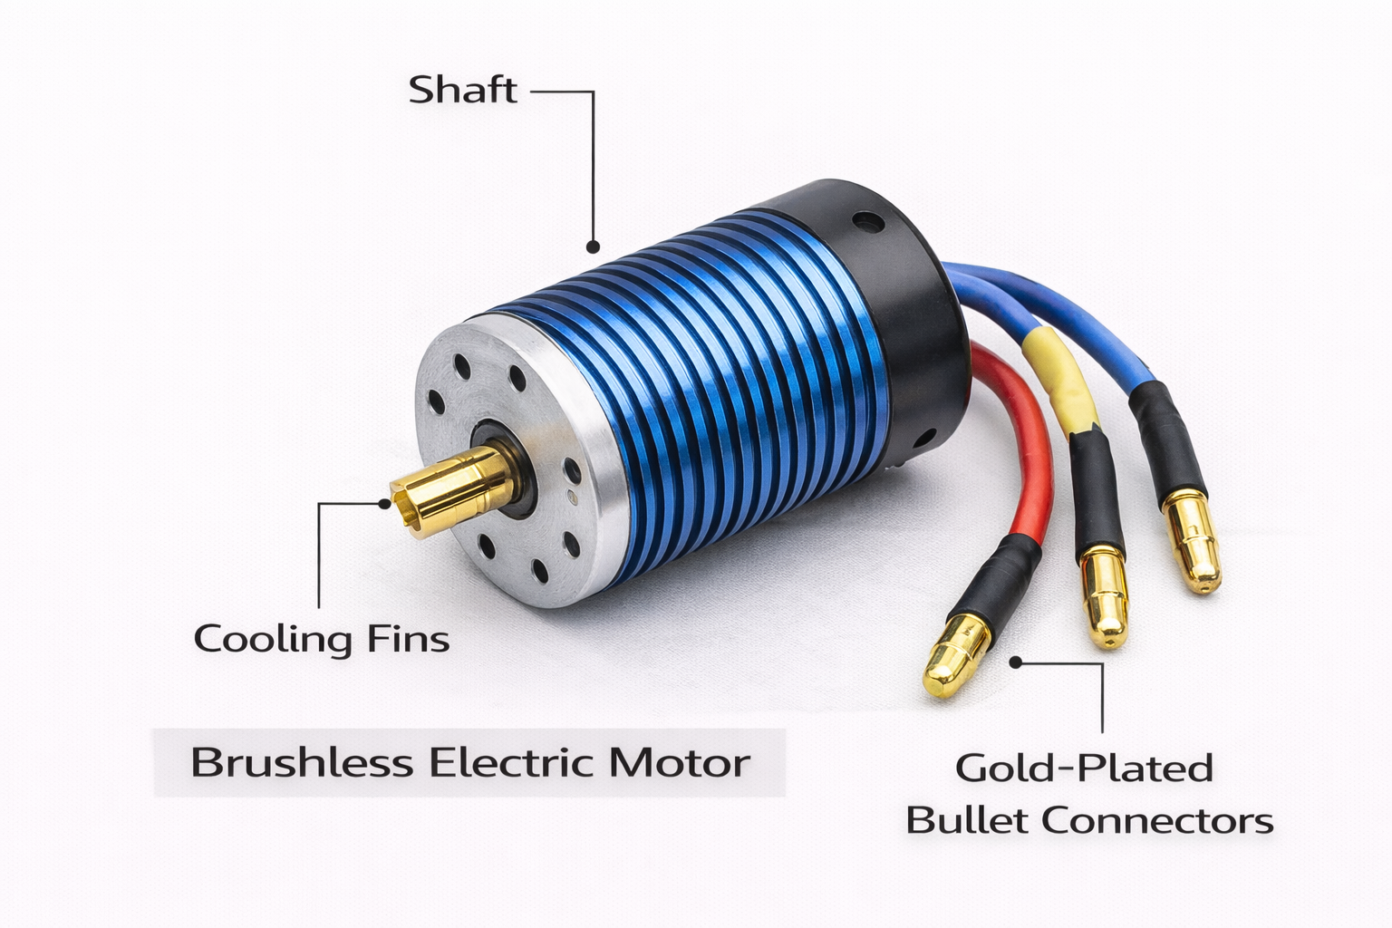

### 4.2 Battery

* The battery supplies power to all electronic components.
* Common battery types include **NiMH** and **Li-ion/LiPo**.
* Battery capacity determines how long the RC car can run. 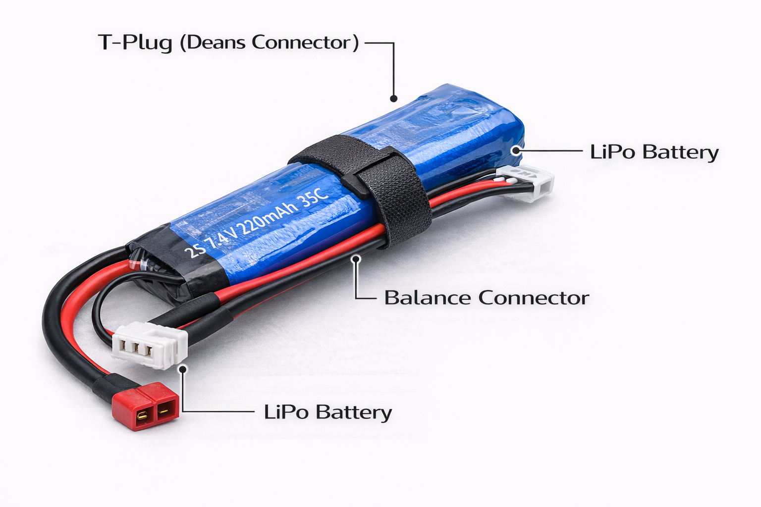

### 4.3 Receiver

* The receiver receives signals from the transmitter (remote control).
* It sends control signals to the ESC and servo motor. 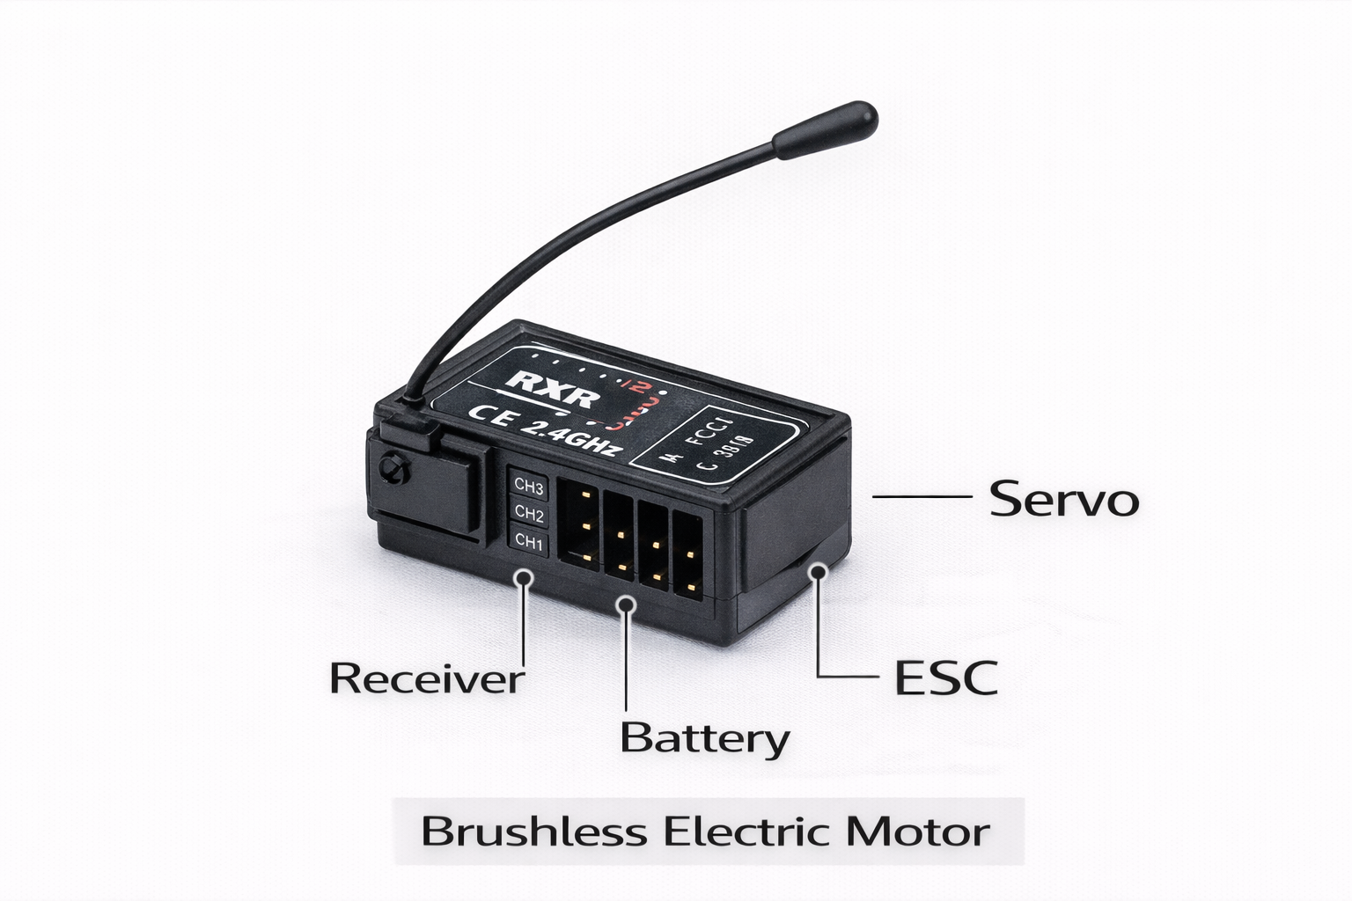

### 4.4 Electronic Speed Controller (ESC)

* The ESC controls the speed and direction of the motor.
* It regulates power flow from the battery to the motor.
* Ensures smooth acceleration and braking.

### 4.5 Servo Motor

* The servo motor controls steering movement.
* It turns the front wheels left or right according to user commands.
* Provides precise and quick steering control. 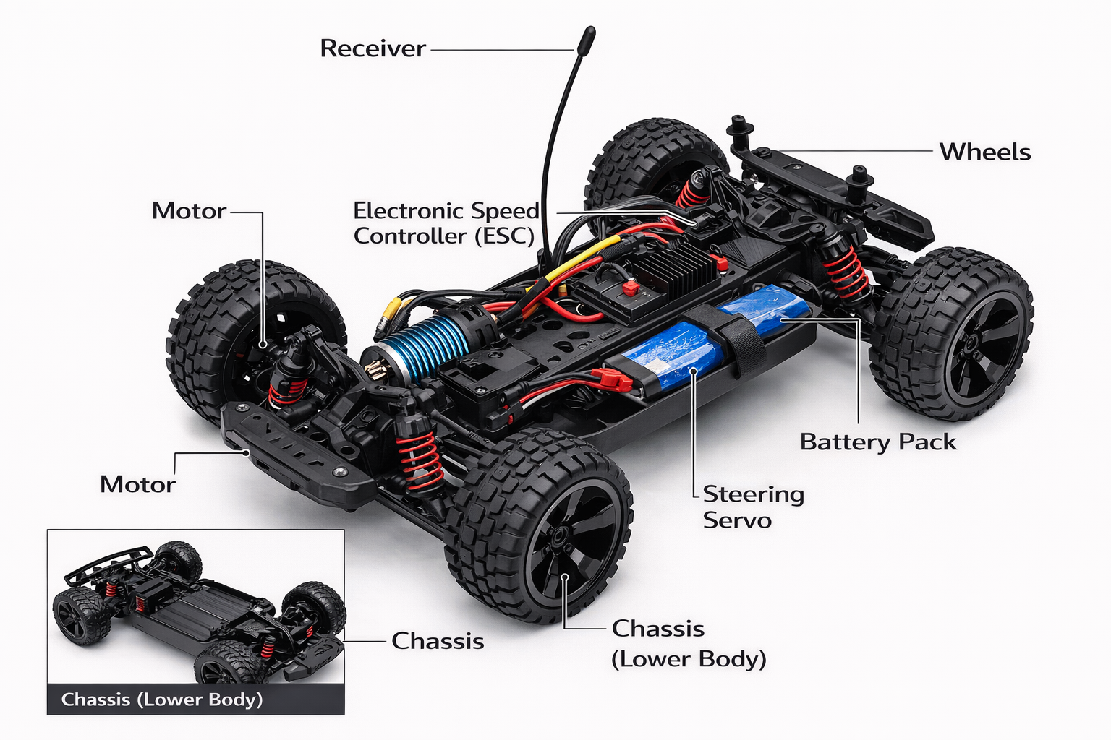

## 5. Working Principle

### The remote controller sends signals to the receiver. The receiver passes commands to the ESC and servo motor. The ESC controls motor speed while the servo controls steering, allowing the RC car to move as desired. Step-by-Step Working

1. **Remote Controller (Transmitter)**
   * The user operates the RC car using a handheld remote control.
   * When buttons or joysticks are pressed, the transmitter generates **radio frequency (RF) signals.**
2. **Radio Signal Transmission**
   * These RF signals are transmitted wirelessly through the air.
   * Each signal carries specific commands such as **forward, reverse, left, or right.**
3. **Receiver Unit**
   * The receiver inside the RC car receives the transmitted signals.
   * It decodes the signals and sends instructions to the control components.
4. **Electronic Speed Controller (ESC)**
   * The ESC receives commands from the receiver.
   * It controls the **speed and direction of the motor** by regulating the power supplied from the battery.
5. **Electric Motor Operation**
   * The motor converts **electrical energy from the battery into mechanical energy.**
   * This mechanical energy rotates the wheels using gears and shafts.
6. **Steering Mechanism (Servo Motor)**
   * The receiver also sends signals to the **servo motor**.
   * The servo motor turns the front wheels **left or right**, allowing steering control.
7. **Battery Power Supply**
   * The battery supplies power to the motor, receiver, ESC, and servo.
   * Without the battery, the RC car cannot operate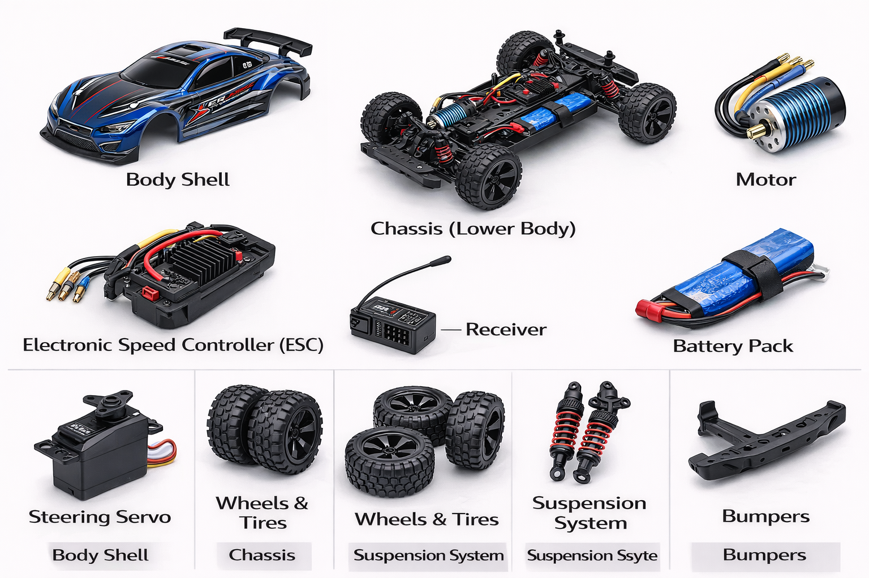.

### Overall Working Flow

**Remote Controller → RF Signals → Receiver → ESC / Servo → Motor & Wheels → Car Movement**

Top of Form

Bottom of Form

## 6. Applications

1. Educational projects, robotics learning, racing competitions, entertainment, and engineering experiments
2. . **Educational Projects**  
   RC cars are widely used in school and engineering projects to demonstrate concepts of motors, batteries, sensors, and wireless communication.
3. **Robotics and Automation Learning**  
   RC cars act as a basic robotic platform for learning robotics, programming, and automation techniques.
4. **Racing and Competitions**  
   RC cars are used in racing events, robotics competitions, and technicalexhibitions, promoting innovation and teamwork.
5. **Entertainment and Hobby Use**  
   RC cars are popular as a recreational hobby for children and adults, providing fun and relaxation.
6. **Research and Development**  
   Engineers use RC cars as test models to experiment with vehicle dynamics, suspension, and control systems.
7. **Surveillance and Monitoring**  
   RC cars can be fitted with cameras and sensors for basic surveillance in restricted or unsafe areas.
8. **Military and Defense Training (Basic Models)**  
   RC vehicles are used for training and demonstration purposes, such as testing remote navigation.
9. **Disaster Management (Prototype Use)**  
   RC cars are used as prototype models for search and rescue operations in hazardous environments.
10. **Advertising and Promotions**  
    RC cars are used in product promotions, exhibitions, and shows to attract attention.
11. **Skill Development**  
    RC cars help in developing technical, mechanical, and coordination skills.

Top of Form

Bottom of Form

## 7. Advantages

Easy to operate, educational, customizable, and fun to use.

• • **Safe and Low Risk**  
Compared to real vehicles, RC cars are **safe to use** and do not require fuel, licenses, or complex safety measures.

• **Customizable and Upgradable**  
RC cars can be modified by upgrading **motors, batteries, wheels, suspension, and body shells,** which enhances learning and performance.

• **Entertainment and Fun**  
RC cars provide **entertainment and stress relief** for users of all ages and are popular as a hobby.

• **Used in Competitions**  
RC cars are used in **racing events, robotics competitions, and technical exhibitions**, encouraging creativity and innovation.

• **Lightweight and Portable**  
RC cars are small, lightweight, and easy to carry, making them convenient for indoor and outdoor use.

• **Environment Friendly**  
Electric RC cars do not produce harmful emissions, making them **eco-friendly.**

• **Cost Effective Learning Tool**  
RC cars are cheaper than real vehicles and lab equipment, yet they offer **practical learning experience.**

## 8. Conclusion

RC cars combine technology and entertainment, making them useful learning tools and enjoyable hobby devices. In conclusion, a Radio Controlled (RC) car is an excellent example of the practical application of electronics, mechanics, and wireless communication. It operates using radio signals from a remote controller, allowing precise control over movement and steering. RC cars are widely used for education, entertainment, and research purposes. They help learners develop technical skills, creativity, and problem-solving ability. Due to their simple construction, safe operation, and wide range of applications, RC cars are an effective learning tool as well as an enjoyable hobby.